**Design Document (Scrapbook Style) - C++**

C++ Design Document:

**Introduction:**

For C++ the paradigm used is Object Oriented Programming. The goals are to implement as many OOP paradigm features whilst not over complicating the code. For example, using excessive classes and inheritance, where the code could be implemented with other features making it more organised and understandable approach whilst still adhering to OOP principles.

**Sketches and Diagrams:**

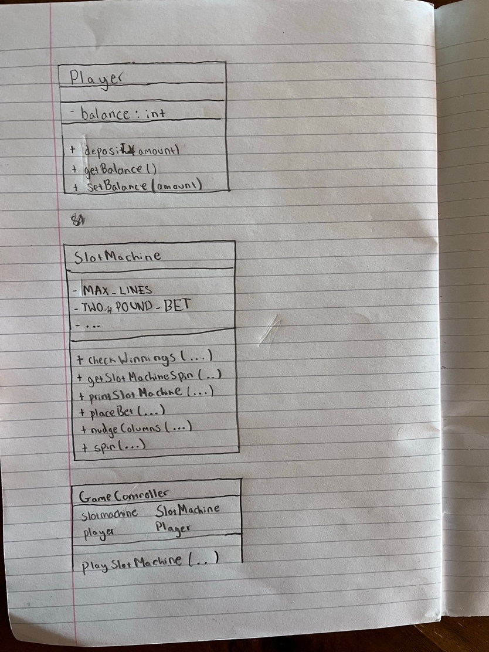



Here is the original rough sketch of the UML. Whilst the final product of the complete code set didn’t fully comprehensively cover it, it was good guide on how to implement the code. The player and GameController mostly stayed the same, however the abstract Slot Machine class was not shown I was unsure how I would implement this in OOP approach. AI interaction 1 suggested a design but was useful at the time as shown.

Here is the final complete UML :

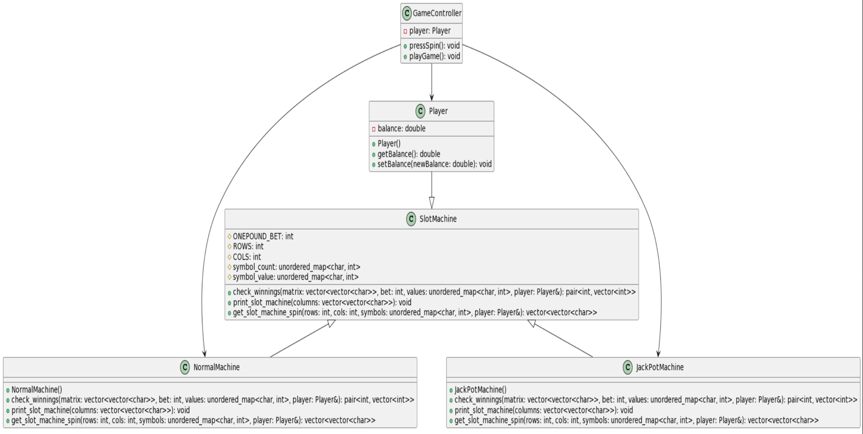

**Pseudocode :**

Pseudo code for the Slot Machine:

* Create Player Class with variables and Setters and getter for cash
* Create Main method
* Create Abstract class SlotMachine with virtual functions for JackPotMachine and NormalMachine to implement.
* NormalMachine:
* Decide variable worth and symbol_count/value for Normal machine.
* Print_slot_machine : iterate over each column in a vector of coulmns printing each symbol followed by a separator
* Get_slot_machine_spin : generate a matrix of characters by shuffling the vector and copying the symbols with rows(x) cols(x)
* Check_winnings : check if all symbols in the middle row of the matrix are the same. Multiply symbol value by bet into winning_lines. Update balance and with winnings.
* JackPotMachine:
* Repeat Process but : Edit Symbol_count/value , increase row column to 5x5.
* Create GameController class with a instance of Player
* pressSpin : Check if players balance is greater than 1 , if so generate Number. Based off the number generate create instance off class. Spin and show slot machine , update balnce
* playGame : Allows the player continuously spin the machine (pressSpin()) until they choose to quite showing balance at the end

**Development Process:**

Firstly, implemented all the constants and variables and the print column method in the Slot Machine class. Verification through Clion made the approach easier with the built in compiler. However, our final approach to the method was changed if you look at AI interaction 2.

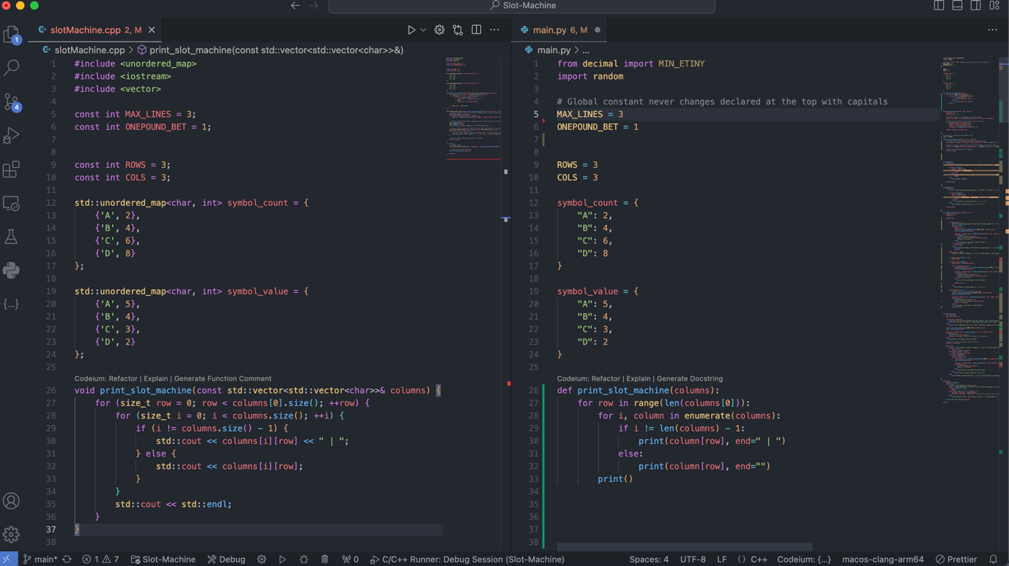

Milestone 2:

At this point it was at basic development, the further features as in winning now be implemented. it would generate new rows and columns in the three-by-three column.

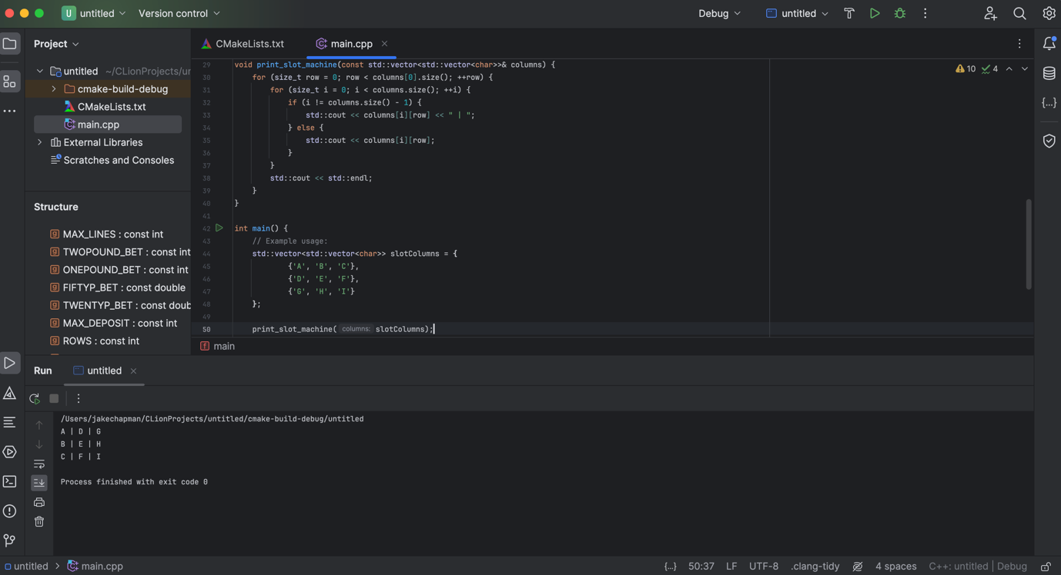

Get slot machine spin method was developed.

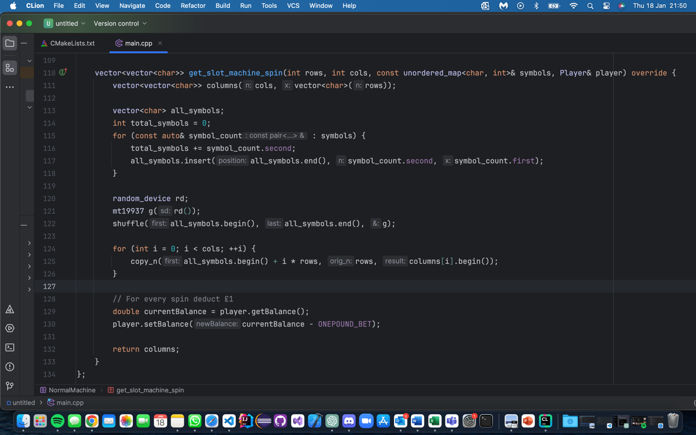

I developed the main method now in combination with the other method to now print a random slot machine combination.

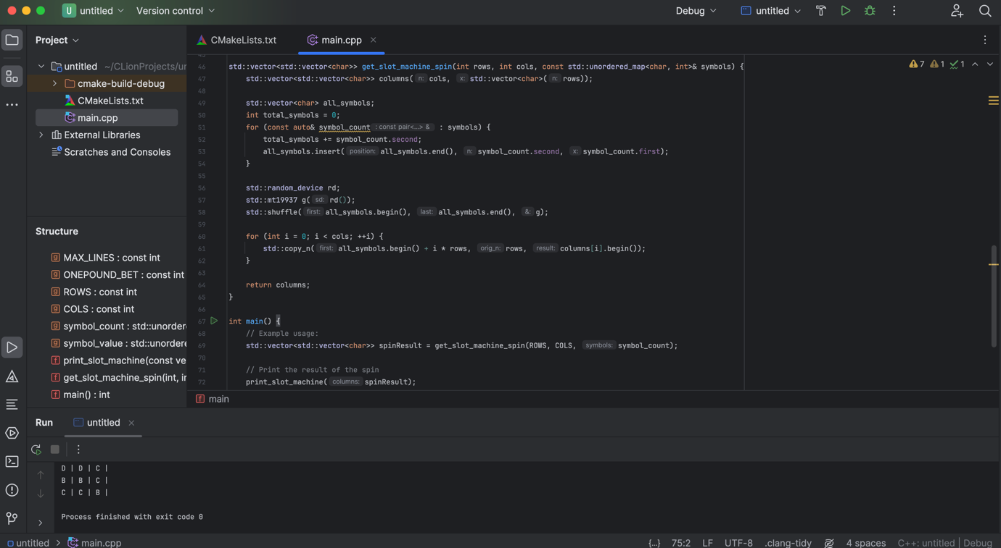

I started to separate the class into player and slot machine class. With attributes and setters and getters specific to the player/class, demonstrating uses of OOP paradigm.

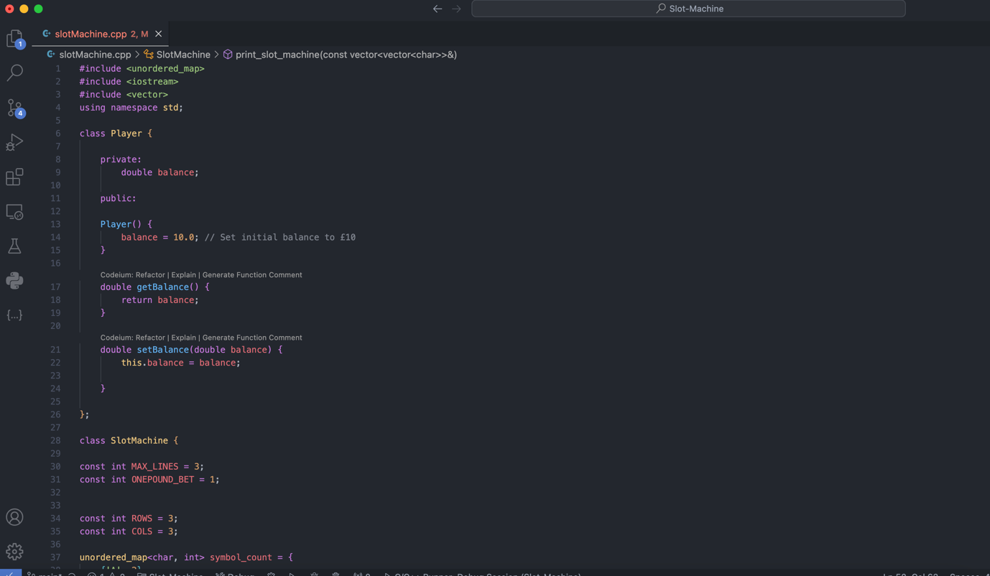

Whilst trying to implement the check winnings method I had a problem matching it properly, cases were does not match a row but wins or matches a row and loses.

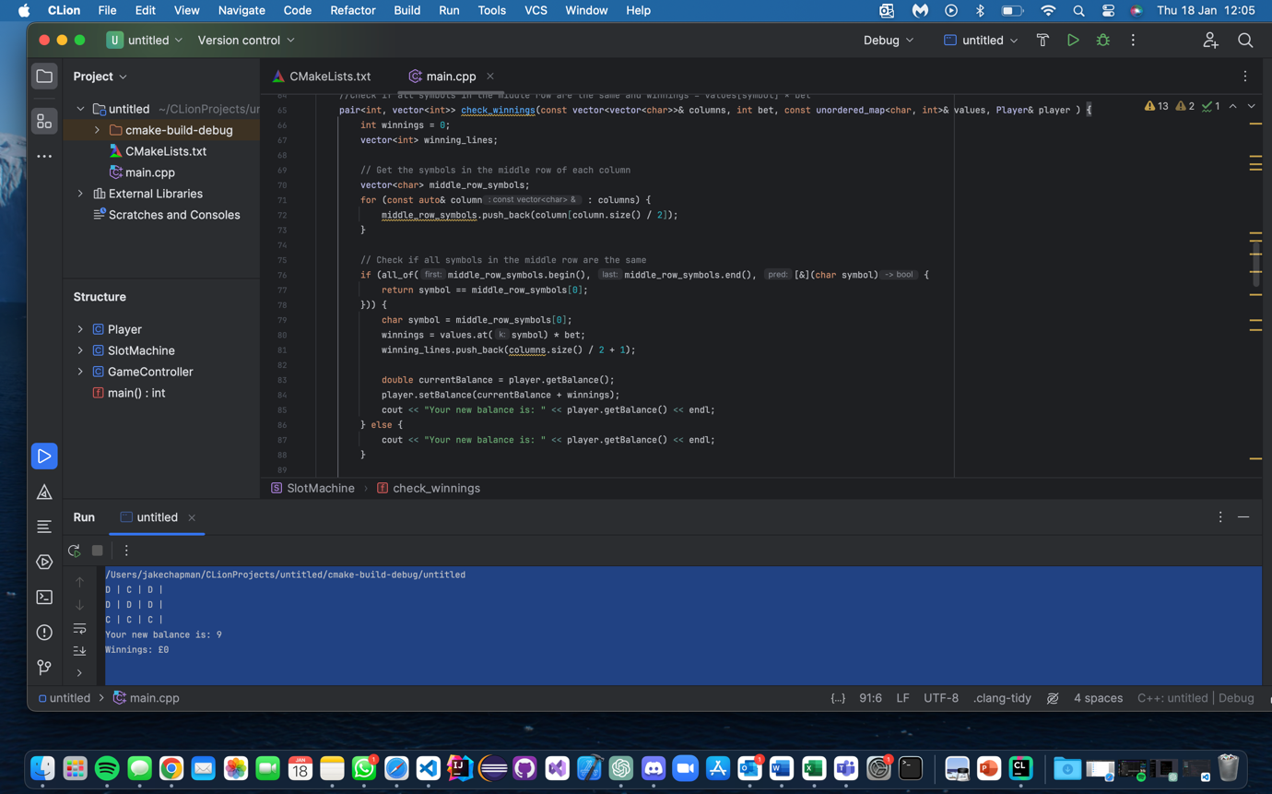

I consequently struggled with this method for a while I went though many processes of debugging. So, I asked codium for assistance to streamline the process. See AI interaction 4 to see.

Now that the winnings were being counted correctly. I created another class Game Controller. This demonstrates more use of OOP by encapsulating the logic of the slot machine. Allowing for better abstraction and organisation of the code set.

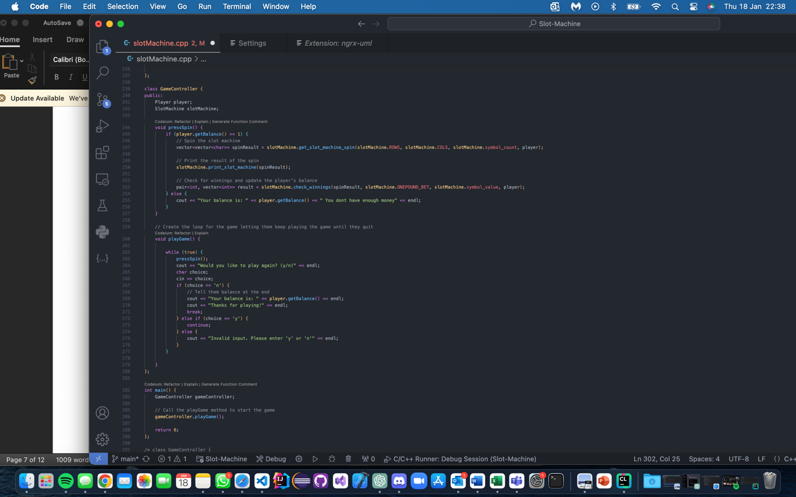

Now to implement the feature of Jackpot Machine. To do this I created an Abstract Class called “SlotMachine”. The original “SlotMachine” class became “NormalMachine”. The new abstract class contained new virtual functions as shown . Demonstrating inheritance and polymorphism, key concepts in OOP.

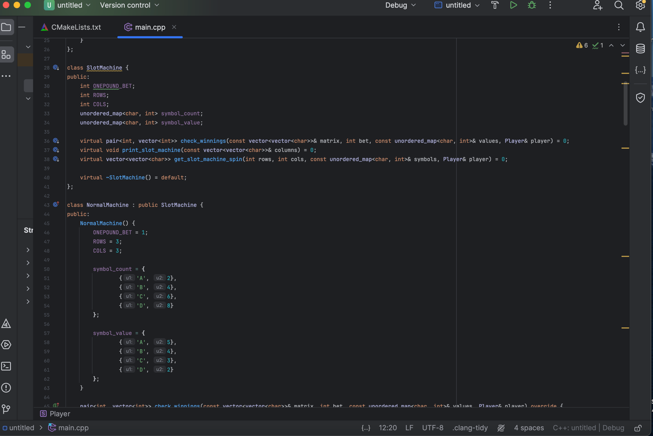

Jackpot was developed with better odds and more cash , it was also implemented with a 5x5 row col for its own virtual function of the print_slot_machine_method.

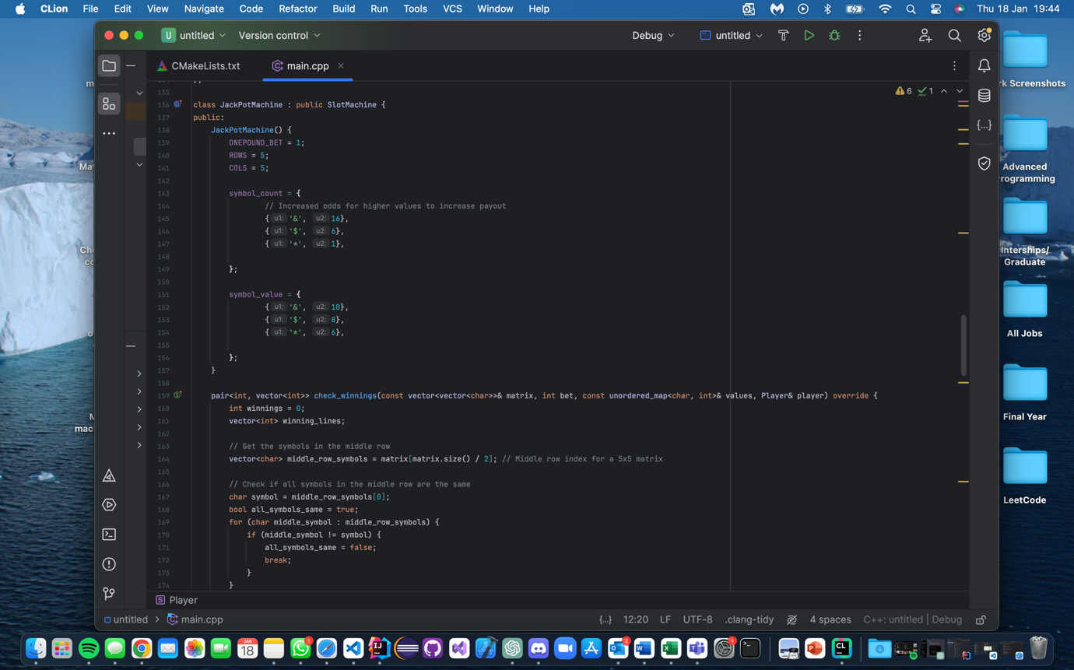

Here I updated the press spin function to include the probability of being entered into the jackpot spin if so that it creates the object of the chosen SlotMachine implementation . Allowing to easily switch between one another.

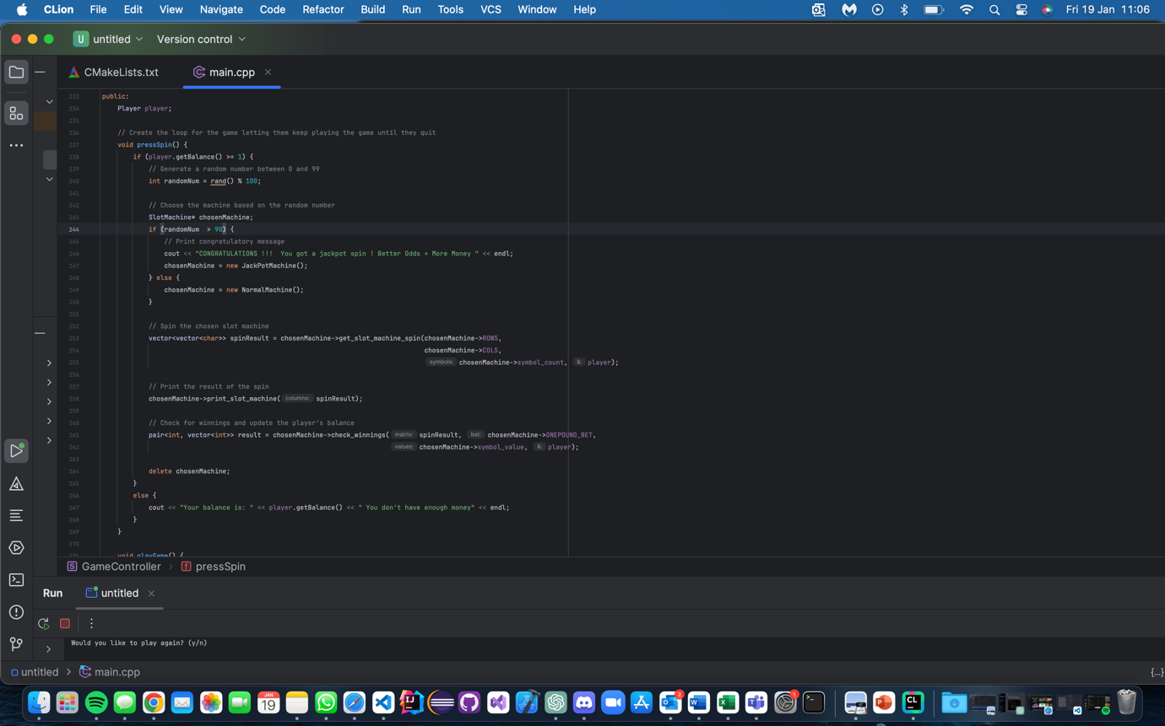

Demonstration of the code working switching from normal to Jackpot slots. Code completed.

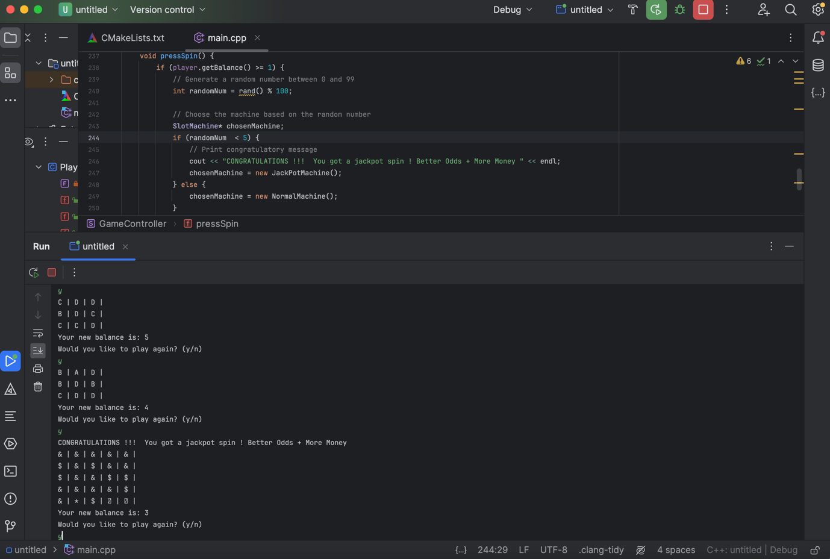

**AI Interaction:**

*AI Interaction 1:*

To assist with the quickly generating my UML based off my already completed python I asked to create the UML for the C++ plus approach. Whilst it managed to differentiate the need for a Player Class in addition to the slot machine class. However it created an abstract class for the connection between the two, which logically didn’t make sense despit it making it more OOP.

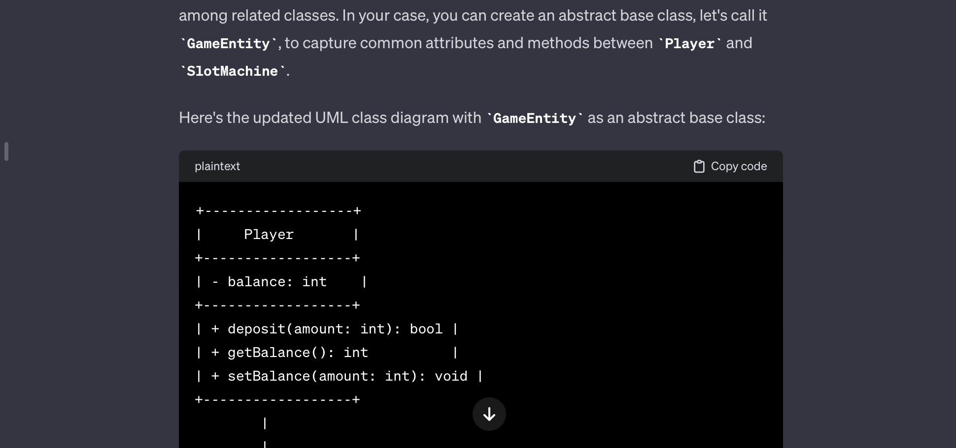

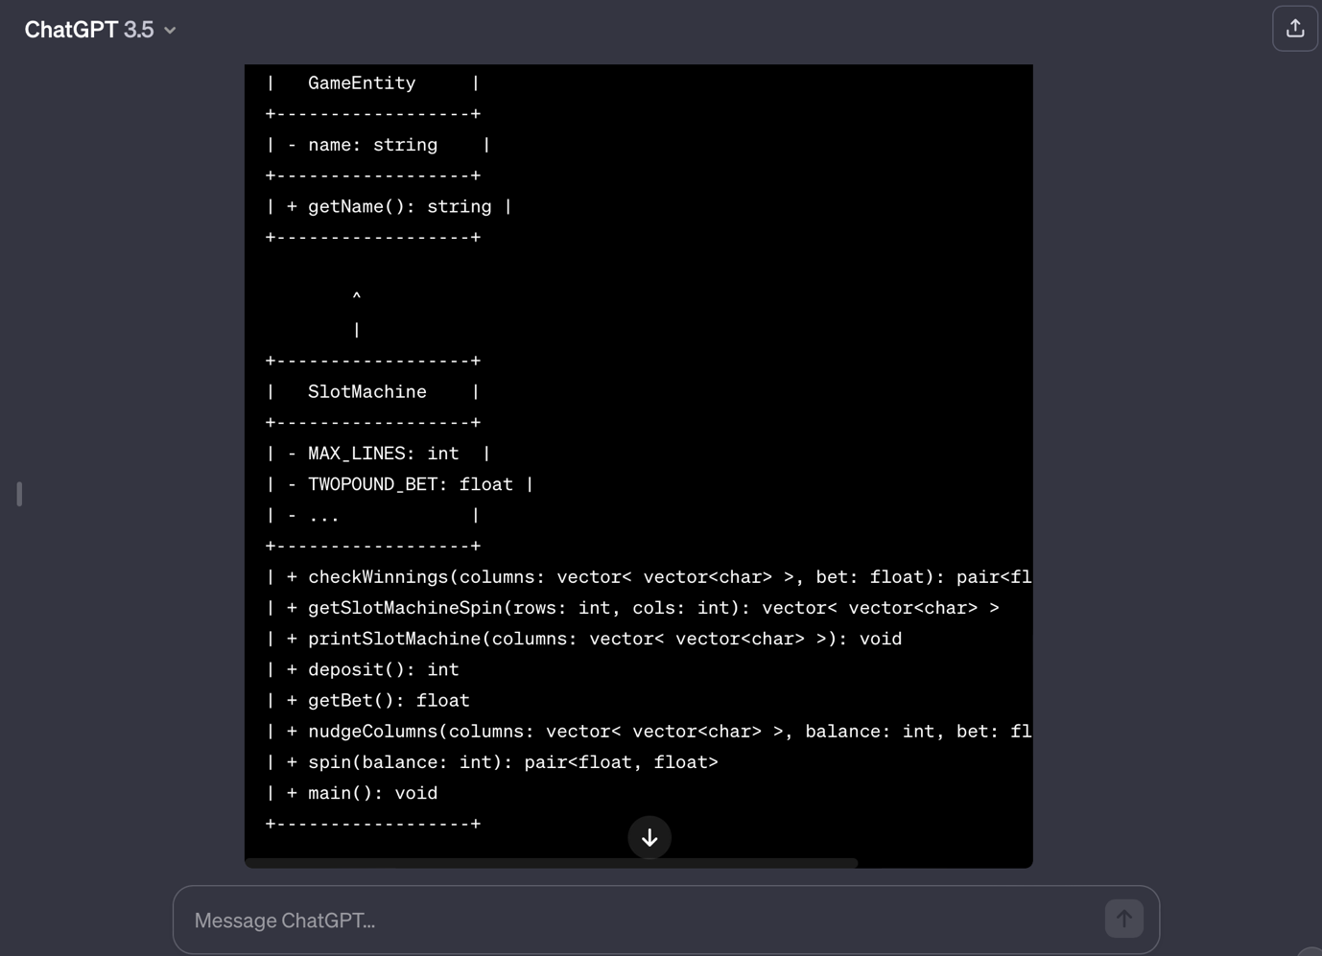

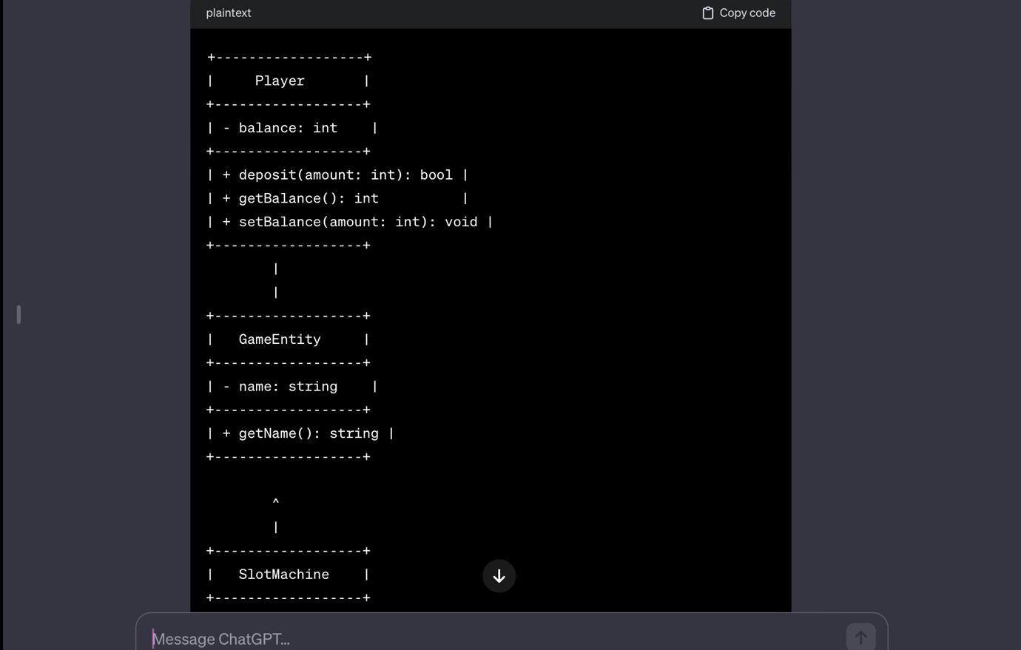

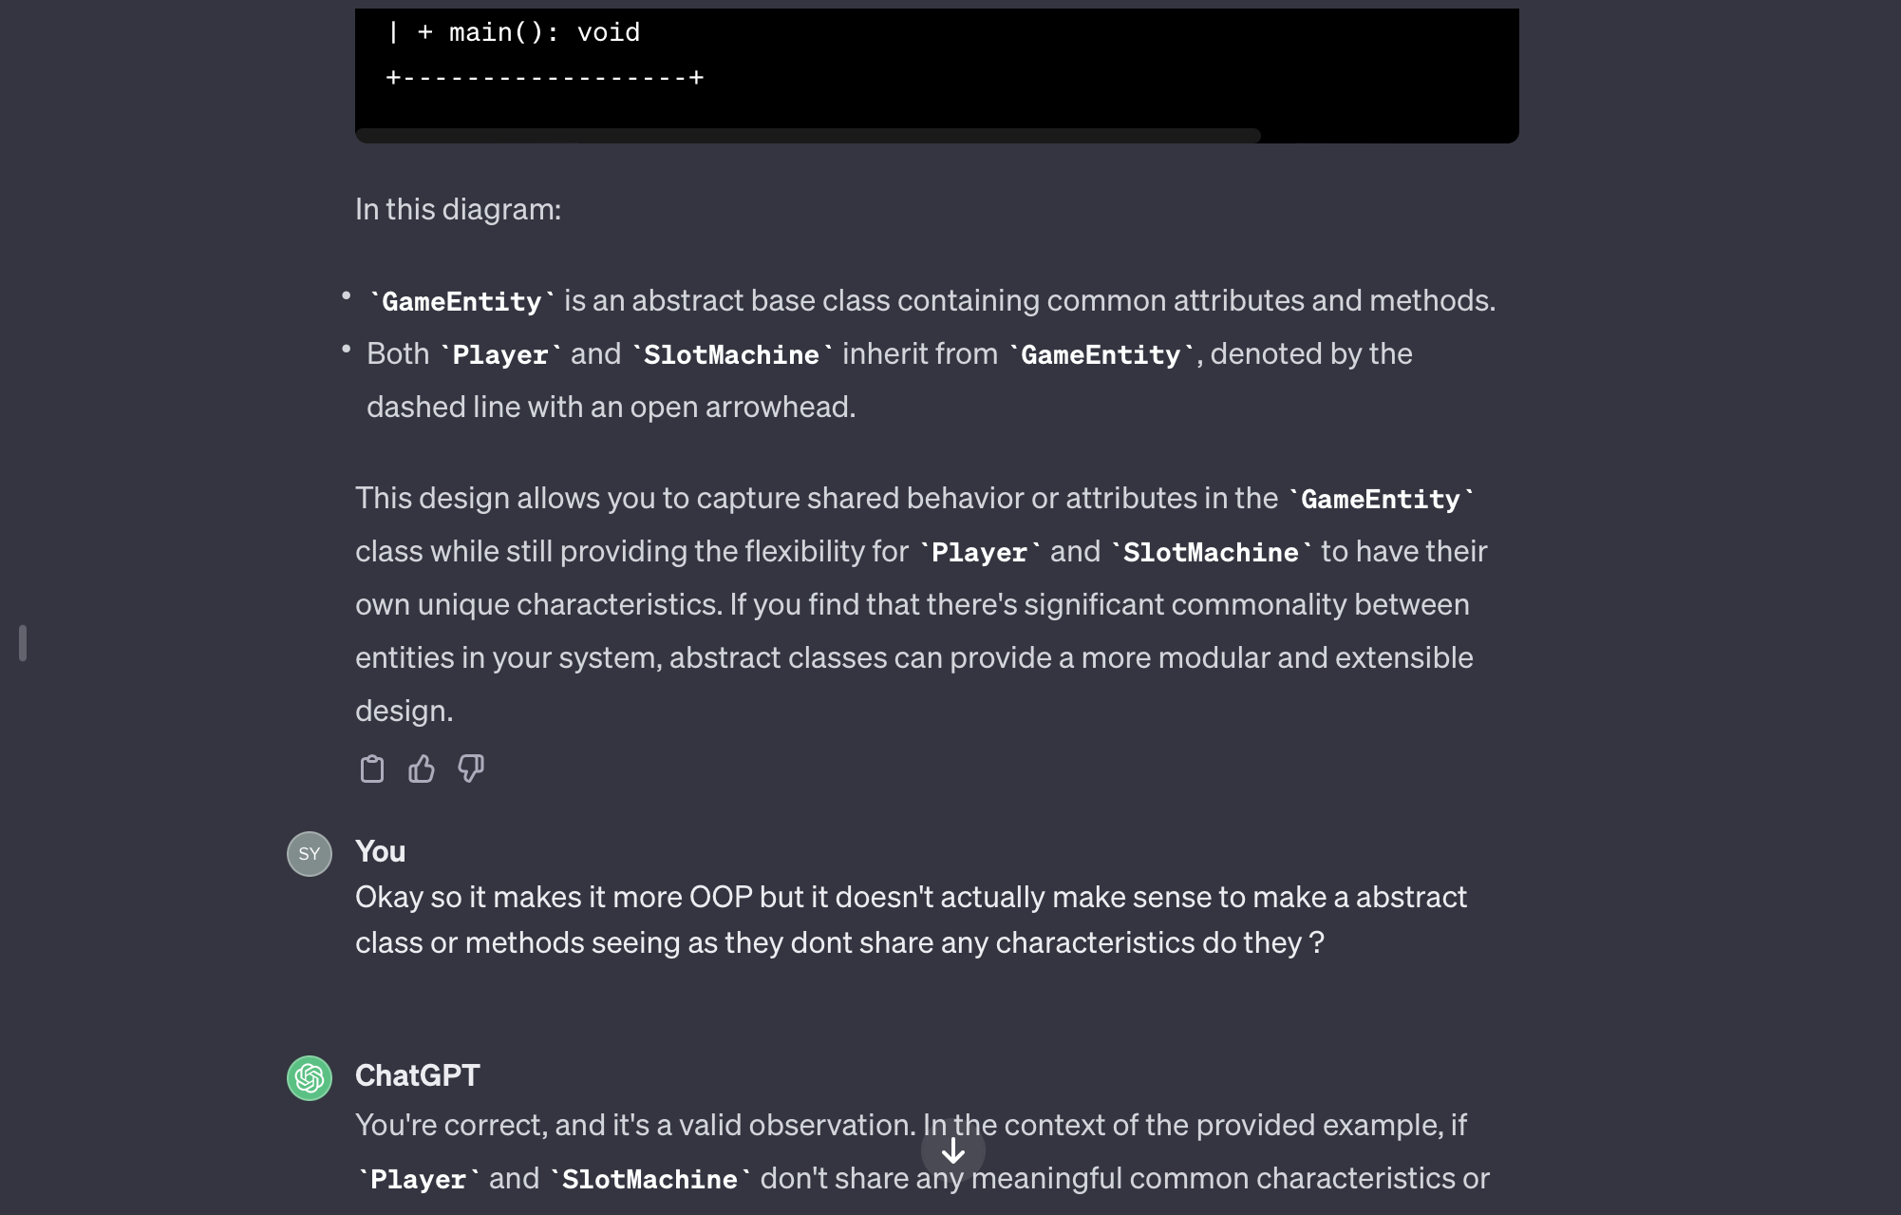

**AI Interaction 2:**

This is a in buit tool I use called codium . It allows you to refactor certain elements of the code as we can see here with my initial code it allows you to refactor methods based off youre code . As we can see with the suggestion is actually a more easily understandable method. Whilst this does not apply with all methods, we can see here it has.

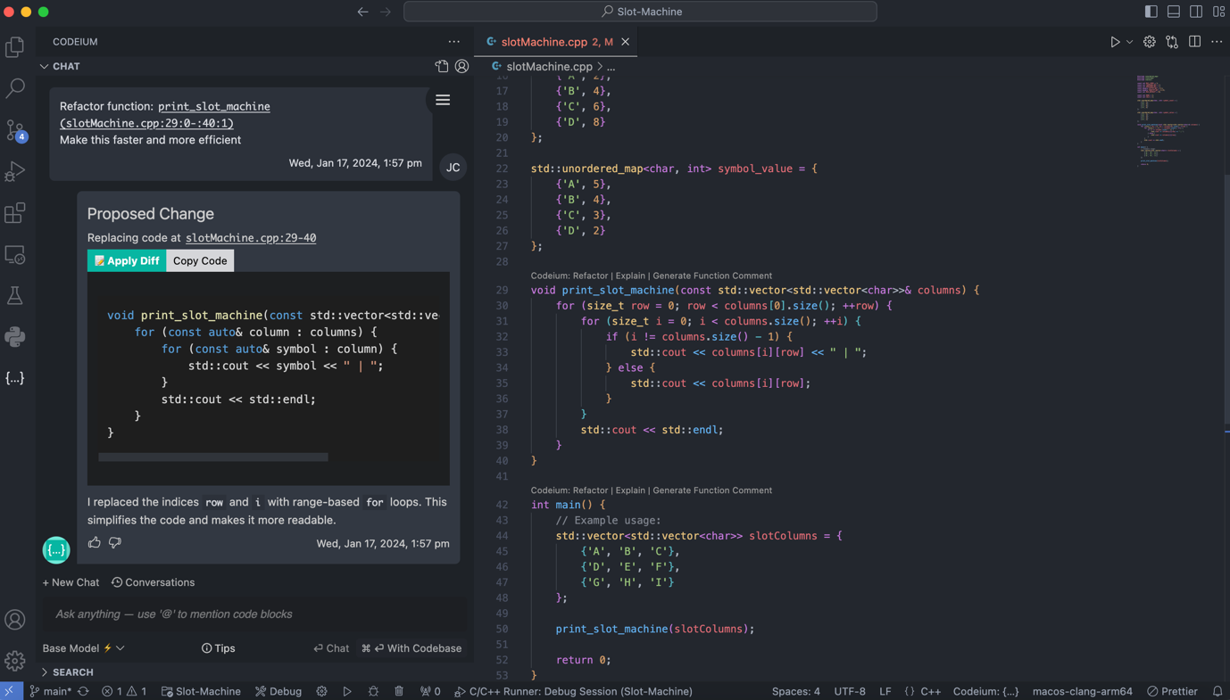

Validation:

We validated the interaction with codieum by running it again giving us the same result as we had previously .

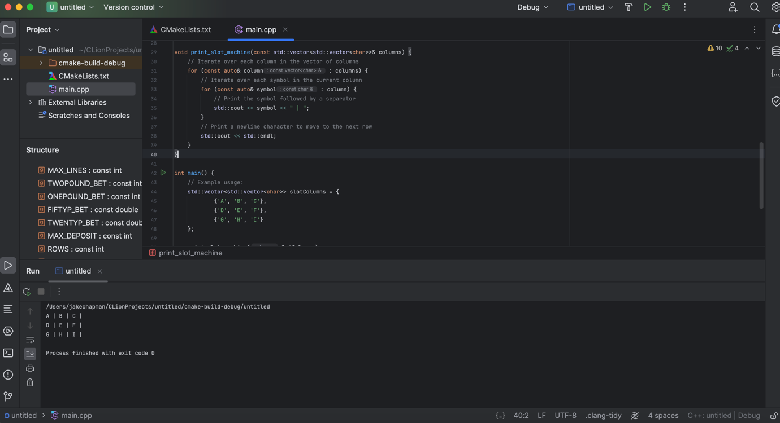

**AI interaction 3:**

Codium also provided a great tool to verbosely comment on code to understand the flow of the methods, this helps people have not read it before understand the method at quicker glance.

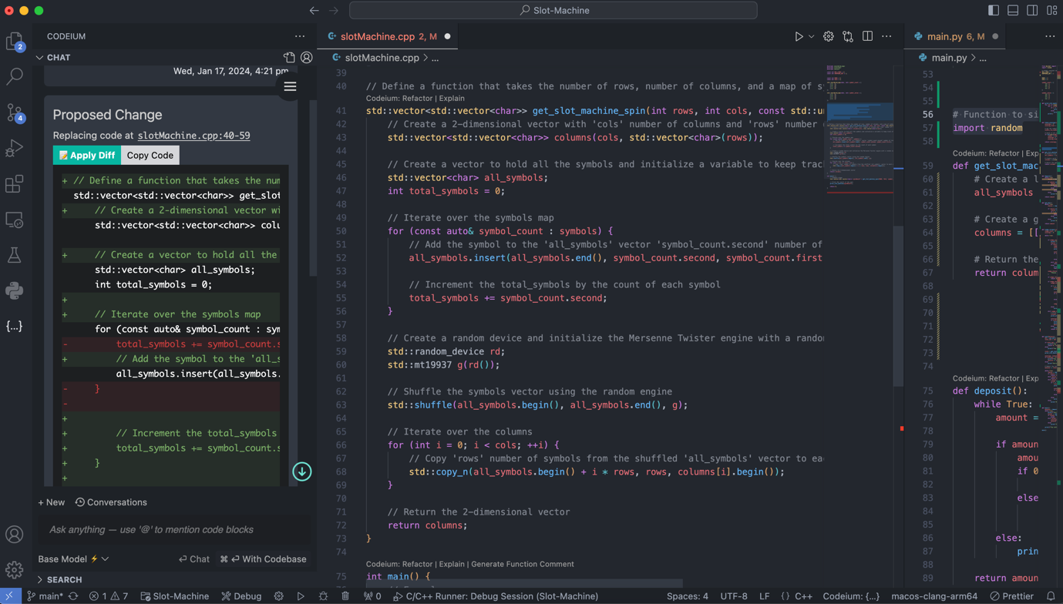

**AI Interaction 4**

